My Visual Schedule: A Printable Picture Schedule for Kids
How to edit this Word file
- Move a card: click in the card, select its picture and its word, then cut (Ctrl+X) and paste (Ctrl+V) into another box. You can also drag the selection.
- Change the words: click the word under a picture and type.
- Swap a picture: right-click the picture and choose Change Picture (Mac: Control-click). Pick your own photo or image.
- Remove a card: select its picture and word and press Delete. The empty box stays so the page does not shift.
- Add a card: copy a card from the picture cards (pages 4–7) and paste it into an empty box.
Tip: the schedule on page 2 has a sample morning routine. Replace or delete those cards to make it your child’s.

A visual schedule shows your child, step by step, what will happen and in what order. It makes routines predictable, which can make transitions calmer and help promote your child’s independence.

How to use your visual schedule
1 | Pick one routine. Start with the hardest time of day, such as mornings or bedtime.
2 | Choose 3–5 steps. Copy the picture cards for each step onto the schedule, or print and cut them out. Start small; you can always add more later.
3 | Put them in order. Place the cards from top to bottom on the schedule strip.
4 | Show and practice. Walk through it together: “Let’s check your schedule.” Help at each step, then give less help over time.
5 | Mark it “all done.” Move the card to the All Done box or check the circle.

Tips
- Keep it where your child can see it.
- Use the same simple words each time.
- Praise each finished step.
- Add a “change” card when something different is coming.

Inside: page 2 My Schedule · page 3 First / Then · pages 4–7 picture cards
Learn more: gentlecaretherapy.com/visual-schedules-making-routines-predictable/
This handout is general education and does not replace advice from your child’s care team.

My Schedule Name: ______________________
 | START HERE ↓ |  |  |  | THEN KEEP GOING ↓
1 |   wake up |   done |  | 4 |   breakfast | done
2 |   bathroom | done |  | 5 |   brush teeth | done
3 |   get dressed | done |  | 6 |   shoes on | done

 | All Done  Put finished cards here.
Tip (optional): Laminate this page and the cards, then add Velcro dots so cards can be moved and used again.

First / Then
First  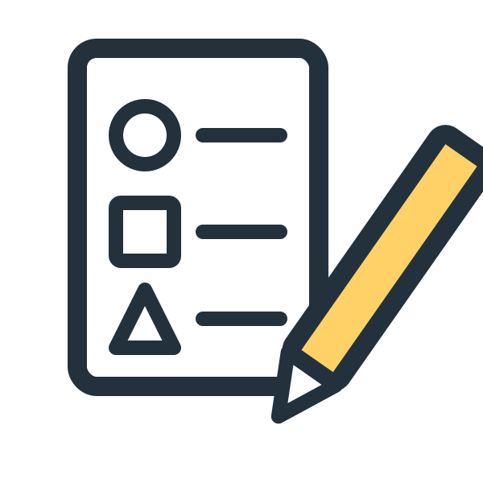  work time |  | Then    play

Tip: Say it the same way each time: “First ___, then ___.” Put the less-preferred task first and something your child enjoys second. The sample cards (work time, play) can be swapped for any two cards.
Learn more: gentlecaretherapy.com/using-first-then-statements-to-support-young-children/
■ Morning ✂ Cut on the lines
wake up | bathroom |   wash hands
get dressed | breakfast | brush teeth
shoes on |   coat on |   backpack
  bus |   car | empty box: paste a card here
■ School and therapy ✂ Cut on the lines
  school | 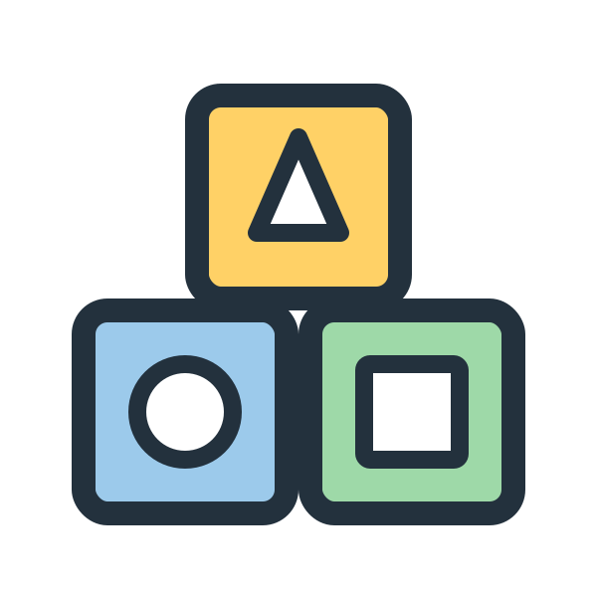  therapy |   circle time
work time |   snack |   lunch
  recess |   go home | empty box: paste a card here
■ After school ■ Bedtime ✂ Cut on the lines
snack | play |   outside
  homework |   tablet time |   dinner
  bath |   pajamas | brush teeth
  book | 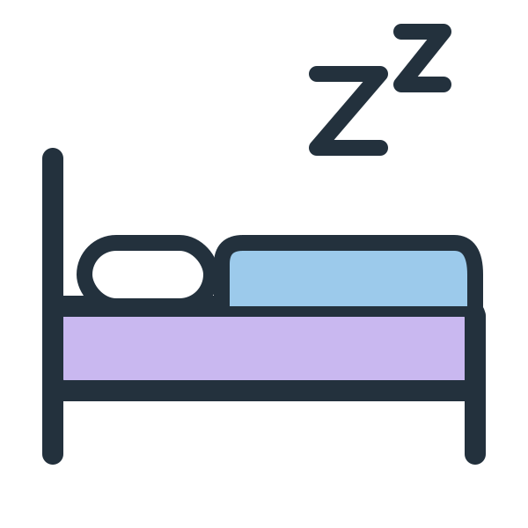  bed | empty box: paste a card here
■ Helpful cards ■ Blank cards ✂ Cut on the lines
all done |   wait |   break
  help |   change |   first
  then | 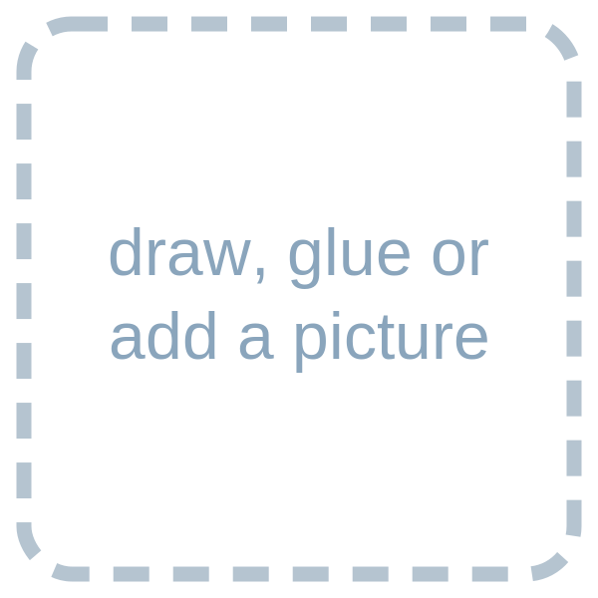  type a word | type a word
type a word | type a word | empty box: paste a card here

